Louis Poirier, BAA, AACI, P.App

Partner

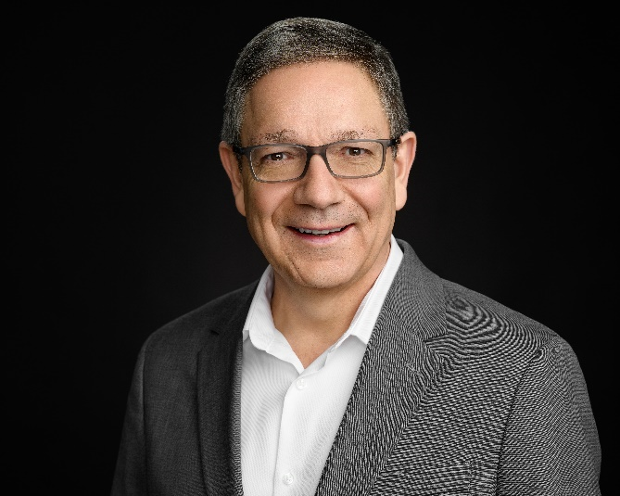

# Profile

Louis has vast experience in property valuation and assessment review services for commercial, industrial, retail, and multi-residential properties. He has acted as expert witness in arbitration, property tax assessment, expropriation, and civil litigation cases, as well as other specialized real estate tribunal matters. Louis has worked extensively in Montréal, Calgary and Atlantic Canada and has provided valuation and consulting services in all the Canadian provinces.

# Accreditation and Memberships

* Accredited Appraiser Canadian Institute (AACI) - 2005
* Member Appraisal Institute of Canada (AIC)
* Past National Board of Directors representative for the provinces of New Brunswick and Québec
* Past President of the New Brunswick Association of Real Estate Appraisers (NBAREA) as well as the Québec Provincial Association (AQICE)
* Past Chairman of the AIC’s Standards Sub-Committee
* Past Counsellor Professional Practice – AIC
* Instructor of the AIC Professional Practice Seminar
* Past Peer Reviewer & Special Reviewer for Professional Practice matters
* Past Chairman of the National Communications Committee – 2006/2007
* Current member of the Canadian Property Tax Association

# Career

* Partner, Poirier & Paquet Valuation Advisory Services specialized in complex property valuation, property tax assessment review, litigation support and consulting, Moncton, New Brunswick.
* VP Moncton, Turner Drake & Partners Ltd., Halifax, Nova Scotia.
* Director, Property Tax Services at CBRE and Ryan, Montréal, Québec.
* Managing Director and Principal AEC SYMMAF, Montréal, Québec.

# Specific Expertise

Valuation, consultation, and expert services for:

* Market value of vacant land for numerous purposes, valuation of multi-residential properties, retail and office buildings, light and large-scale industrial properties, institutional and stand-alone retail properties, power centres and shopping malls.
* Multi-year analysis of land uses for residential and commercial property developments.
* Assessment reviews and assessment appeals of a single property or portfolios.
* Market value for expropriation negotiations and settlements.
* Replacement value for real property insurance.
* Lease audits, recharge reviews and lease arbitration support for renewals.
* Expert witness before the administrative tribunals and Superior Court in Québec, Court of King’s Bench in Alberta, Payments in Lieu of Taxes Dispute Advisory Panel (PILT DAP) in Ontario, and multiple lease arbitrations in Québec and New Brunswick.
* Review assignments for compliance and litigation support.